Natural Language Processing (NLP) Techniques Report

1. Identify, show the main variables and describe a problem in your course work project that can be addressed using chatbots
2. se any available platforms to develop a simulation of a chatbot to demonstrate how the problem in task1 can be addressed

Introduction

In this report, I will describe and demonstrate several key Natural Language Processing (NLP) techniques using Python with NLTK (Natural Language Toolkit). NLP techniques are essential for processing and understanding human language, making them valuable tools in various applications.

Sample Code

I have implemented a Python code snippet that showcases the following NLP techniques:

1. Tokenization

2. Stemming

3. Lemmatization

4. Normalization (removing stopwords and converting to lowercase)

5. Named Entity Recognition (NER)

**Below are the steps i used to achieve my NLP project**

**1)Installed the nlkt library**



**2)i had to load the dependancies to used**

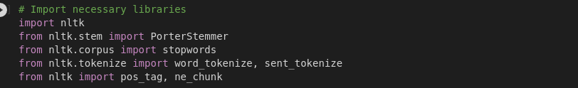

**3) I had to download the dataset using the ntlk library**

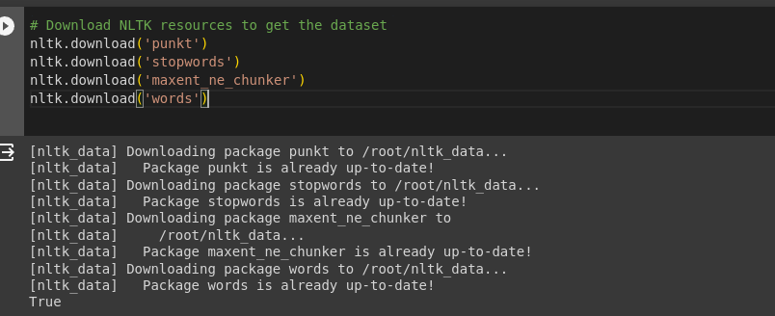

**4)I had to a sample demo to pefrom Natual Language Techniques**



**5) Tokenizing Where i used the keyword word_tokenize to spilt the text into words**

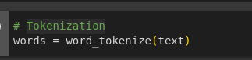

**6) I Stemming Reducing words to their base form.**

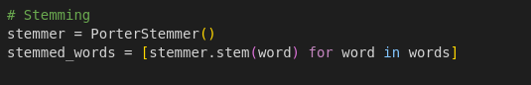

**7) I Lemmatized Reducing words to their dictionary form.**

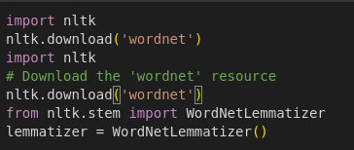

**8)I had to perform Normalization Making text consistent and uniform.**



**9) I had to NER: Identifying and categorizing named entities in text.**

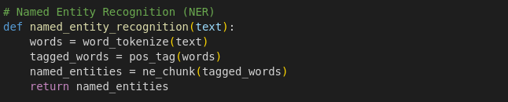

**Here is the results**

